Week 6:
Networking
Networking is a fundamental requirement for Shredded squad app allowing maintenance and retrival of data from APIs stored in the internet
The code ensures that the app cannot proceed without internet connection.
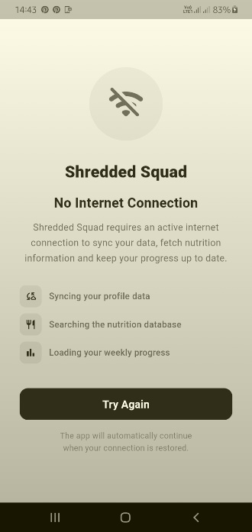
Otherwise it proceeds to the login screen if internet connection is available

